# Percival Growth Chamber Quick Start Guide

Compiled by Jeff Chieppa with edits & additions by Evan Perkowski and Kelly Carroll

# Important access information:

Chamber emails: [SmithLabTTU@gmail.com](mailto:SmithLabTTU@gmail.com)

Password: gogochamber17

DOB for Gmail account: April 15, 1912

# Operating Instructions:

## If you are turning the chambers on after they’ve been off…

When turning on the chambers, provide them ~10 minutes to warm up. Alternatively, you can open the top hatch (using a flathead screwdriver) to find the Netgate router. Once the green light stops blinking below the black diamond (red circle), the chamber is ready to be interacted with.

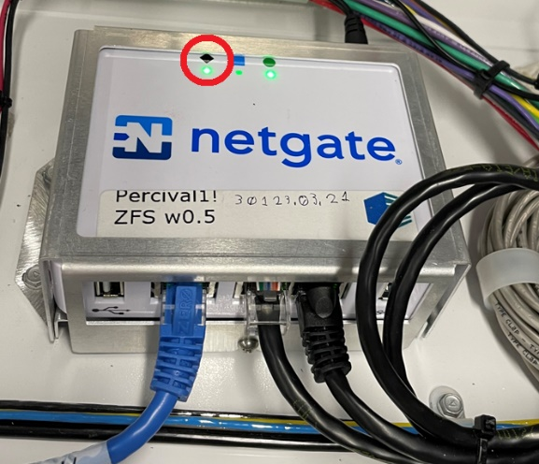

Once the chamber is ready, you will need to reboot the software.

To do this, activate the touchpad by tapping it. Click the square on the touchpad, swipe the login screen left or right to close it. Give it ~30 seconds before reopening the login screen. Touch the Percival logo button to reopen the login screen (red circle). Wait until the temperature is shown in Celsius before attempting to log in. No password is required.

# Navigating the On-Screen Software:

When first opening the software on the touchpad, this will be your welcome screen. It displays most of the information you need to ensure that the chamber is running correctly at a glance, most importantly including (from top left to bottom right): chamber internal time, the program that is running (or that the chamber is in manual mode), the light level, a graph of temperature over time, the current temperature, the current relative humidity, the current CO2 concentration, the current alarm status.

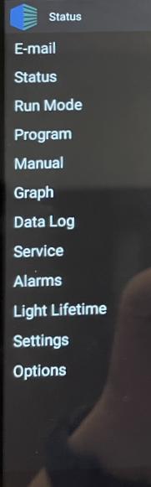To reach the Menu, click on the Percival logo in the top left corner of the screen (red circle). This will show you the list of options on the left. If you need to set the chambers to run to a different program, or create a new program, you will want the “Program” tab (red box). That will open a drop-down in the Menu with options like “Multi-Step” and “Sequence”. You will want to select “Multi-Step” if your program will have both a day and a night cycle.

Once you reach the “Multi-Step” screen and have either selected an existing program or created a new one (using the “Add Prog.” button), you will see something like the below, showing the steps of the program and allowing you to add steps to your program or modify the steps already present. This can also be done remotely using the IP linkup discussed below, and that method is simpler.

# To access individual chambers remotely (from ESBII):

Use a web browser that allows permits cross-origin resource sharing (CORS) such as “CORS Unblock” plug-in for Google Chrome.

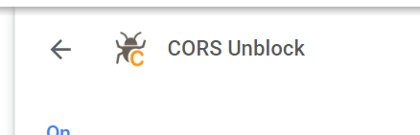

Once CORS is set-up, enter the chamber IP address into your web browser.

|  |  |  |
| --- | --- | --- |
| **Chamber #** | **Chamber Name** | **IP Address** |
| 1 (near door) | Simon | 10.135.27.144 |
| 2 | Randy | 10.135.27.28 |
| 3 | Ryan | 10.135.27.152 |
| 4 | Paula | 10.135.27.155 |
| 5 | Britney | 10.135.27.29 |
| 6 (near CO2) | Demi | 10.135.27.154 |

*Note: These IP addresses may be in flux (as of 7/19/2023) due to IT trying to fix their remote accessibility. This file will be updated once that issue is resolved.

The username and password to access the chamber will be: U: ADMIN; P: PSIADMIN (all caps)

The “Monitor” tab will show the input status, lighting status, operation mode (whether a program is running or manual controls), and if a program is running it will show the steps.

To set the chamber manually, go to the “Manual Settings” tab. Enter the values you’d like, and hit ‘Save’ then ‘Run’ to reset the manual controls.

## To build a program, go to the “Programming” tab.

Either create a new program (which requires a short name -> create) or highlight an existing program to edit/view.

If building a new program:

* Set time (e.g. 9:00 AM, 11:00 PM)
* Set temperature, humidity, and CO2 (auxillary)
* Set the shelf lighting:
  + Labels for lights run 1-8

|  |  |  |
| --- | --- | --- |
| **Lighting #** | **Shelf** | **Light color** |
| 1 | Top | White LEDs |
| 2 | Top | Red LEDs |
| 3 | Top | Blue LEDs |
| 4 | Top | Far-red LEDS |
| 5 | Bottom | White LEDs |
| 6 | Bottom | Red LEDs |
| 7 | Bottom | Blue LEDs |
| 8 | Bottom | Far-red LEDS |

Then add the Step # and click Add Step.

Repeat this process to build a new program.

To modify a program, it’s a very similar process. The exception is that you’ll put the Step # in you’d like to modify and click Modify Step (rather than Add Step).

# Chamber Maximums & Minimums:

*Possible Temperature Range:*

Lights on: 10 - 44℃ ± 0.5℃

Lights off: 2 - 44℃ ± 0.5℃

*Maximum growing height:* 20.5 in / 52.1 cm

*Maximum light intensity (set to 100% intensity), as given in the manual*:

At 6 in/15 cm from the light canopy: 1550 µmol/m2/s (at 24℃)

At 20 in/50 cm from the light canopy: 1050 µmol/m2/s (at 24℃)

*Minimum humidity:* 13-15% RH

Note: High RH will cause excessive pooling of water in the base of the machine, and will therefore require to be manually drained into the vacuum multiple times daily. Excessive pooling of water at the base of the machine will cause the machine to rust. Chambers should be drained as frequently as needed to avoid machine damage. At minimum, chambers should be drained once per day regardless of humidity setting.

# Alarms:

Only temperature alarms can be set (no light, humidity, or CO2 alarms can be set). If you can configure this, feel free to.

You can set an upper and lower temperature limit at which an alarm would signal.

To do this you’ll need to physically access the chambers (doesn’t appear to consistently work attempting this remotely).

Tap to sign into the chamber, in the top left hit the Status button, go to Alarms in the menu mentioned above in the Software section. Here you can manually set the temperature thresholds that trigger an alarm.

If you’d like to receive emails when these alarms go off, tap the Status button, go to E-mail, and add your email to the list.

# Access chamber data:

To get the chambers accessible via a network computer to download data, we needed to designate an individual computer for all chambers to search for. So, each chamber has the 96well computer IP address programmed into it.

But, I made it so you can access all the chambers by entering the 96well IP address into your web browser followed by the chamber lookup ID (**10.135.27.133:9664**). I’ve only tested this from campus.

## *The username and password*

U: admin; P: admin

To view the chamber data in real time, click on the Chambers tab and select the chamber of interest. You can use the drop-down menus on the left and right side of the graph to select the variables you want to view. Towards the bottom of the page, you can move the window to select a timeframe to view the data.

To download the data, click the Exports tab. From the drop-down menu, select the chamber of interest, also select the Start/End dates and times, and a description of the download. Hit +Add Export to download the data.

# Actual Light Settings:

The light settings can range from 0-100 (basically a percent of maximum). Here is a breakdown of how the light setting affect photosynthetically active radiation (umol m-2 s-1) as measured by Ozzie (Li6800 quantum sensor). You can find more information on wavelengths, ratios, and technical info here: https://www.percival-scientific.com/lighting/scibrite/.

|  |  |  |  |  |  |  |
| --- | --- | --- | --- | --- | --- | --- |
| Light Setting | Chamber 1 | Chamber 2 | Chamber 3 | Chamber 4 | Chamber 5 | Chamber 6 |
| 0 | 0 | 0 | 0 | 0 | 0 | 0 |
| 10 | 107 | 106 | 119 | 123 | 112 | 107 |
| 20 | 222 | 220 | 220 | 228 | 233 | 222 |
| 30 | 327 | 325 | 324 | 337 | 344 | 328 |
| 40 | 443 | 440 | 439 | 456 | 466 | 444 |
| 50 | 552 | 547 | 548 | 568 | 581 | 552 |
| 60 | 615 | 610 | 611 | 634 | 649 | 616 |
| 70 | 705 | 700 | 700 | 727 | 744 | 706 |
| 80 | 877 | 870 | 871 | 905 | 926 | 879 |
| 90 | 1004 | 996 | 998 | 1037 | 1061 | 1006 |
| 100 | 1225 | 1215 | 1217 | 1265 | 1295 | 1228 |

# CHAMBER CALIBRATION [CRITICAL BEFORE EACH EXPERIMENT]

## CO2 Offsets [Old]:

The CO2 sensors within the chambers do not match our LI6800s (which were all cross calibrated prior to collecting these data). Each chamber was set to 200, 420, 1000 ppm CO2 for ~1 hour while a Licor was logging data ~5 minutes (chambers record once every minute). There are the offsets for each chamber resulting from these tests.

Importantly, if the chamber was set at 1000 ppm from 13:00-14:00 for example, both from the Licor and the chamber were subset to reflect 13:05-13:55 in this table. So, the data in this table do not capture transitions between CO2 setpoints in the chamber. Figures are below the table.

|  |  |  |  |  |
| --- | --- | --- | --- | --- |
| **Chamber** | **Chamber CO2 setpoint** | **Chamber CO2 reading** | **Licor CO2 reading** | **CO2 offset** |
| 1 | 200 | 317.04 | 384.30 | -67.26 |
|  | 420 | 424.52 | 513.87 | -89.35 |
|  | 1000 | 1000.42 | 1192.55 | -192.13 |
| 2 | 200 | 308.82 | 397.38 | -88.56 |
|  | 420 | 424.82 | 534.19 | -109.37 |
|  | 1000 | 999.04 | 1199.85 | -200.81 |
| 3 | 200 | 336.50 | 378.66 | -42.16 |
|  | 420 | 426.00 | 484.87 | -58.87 |
|  | 1000 | 1022.00 | 1212.50 | -190.50 |
| 4 | 200 | 320.80 | 358.92 | -38.12 |
|  | 420 | 423.84 | 487.96 | -64.12 |
|  | 1000 | 712.08* | 906.04 | -193.96 |
| 5 | 200 | 339.82 | 474.88 | -135.06 |
|  | 420 | 427.08 | 491.33 | -64.25 |
|  | 1000 | 999.15 | 1237.86 | -238.71 |
| 6 | 200 | 356.54 | 564.02 | -207.48 |
|  | 420 | 423.56 | 469.11 | -45.55 |
|  | 1000 | 992.15 | 1227.64 | -235.49 |

\***It is recommended to verify these offsets using an LI6800 and the same protocol before beginning your experiment**. This is because chamber calibrations tend to drift with time, so doing a proper calibration before each experiment will ensure that your stated CO2 values are verified and recorded as correct.

## Chamber offset figures:

Chamber 1

Chamber 2

Chamber 3

Chamber 4

Chamber 5

Chamber 6

## Temperature, RH, and CO2 Calibrations:

This protocol was developed by Evan Perkowski and [can be found on this GitHub](https://github.com/eaperkowski/2022_NxCO2xI/tree/main/chamber_calibrations). It can also be used to calibrate the CO2 and RH offsets at the time of experiment onset, as recommended above.

**NOTE:** This process is recommended to take *at bare minimum one week if calibrating across all machines (~2 days per machine)*, and realistically will likely require another week or more of data analysis and fine-tuning, potentially involving another set of measurements. Do not assume that a spot-calibration (setting the chamber overall temperature offset based on one timepoint of measurement at one temperature) will provide an accurate and correct calibration across the entire program. This is particularly important because the temperature offsets are different at different temperatures. At minimum, one should calibrate the daytime maximum and nighttime minimum temperature.

When beginning temperature calibrations, set your desired program to run and place a fully charged LI6800 into the chamber with data logging turned on. Allow the chamber (and LI6800) to run for one full cycle of your program (through all of the temperature step changes, including back to the first step, allowing a little extra time (~1hr) at the end for the temperature to stabilize at the final setpoint).

Once the program has completed all of the temperature shifts that your program requires, you can remove the LI6800 and download the logged data from that machine and the chamber itself.

Once you have that data, you can use [the code provided in Evan’s GitHub](https://github.com/eaperkowski/2022_NxCO2xI/blob/main/chamber_calibrations/calib_initial_scripts/chamber1_1000ppm_calib.R) to produce graphs of the chamber’s measured conditions versus the LI6800’s “actual” conditions, as well as solve for the recommended offset for day & night CO2, day & night RH, and temperature at each of your setpoints.

## Setting the Offsets:

The offsets can be adjusted in the Calibration Settings window, found under the Settings menu option (red box).

To change the offset of a given variable, type in the value you solved for using the above code and your collected data.

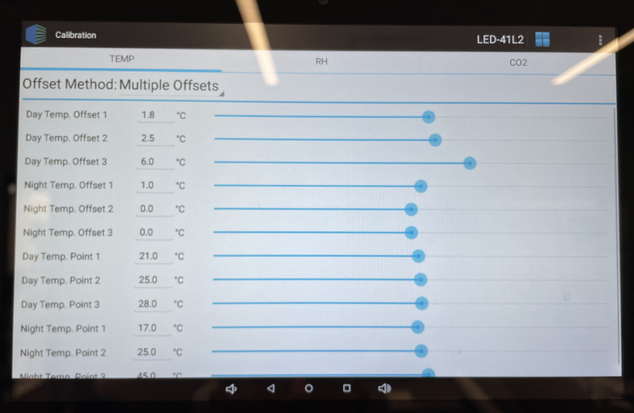Temp.

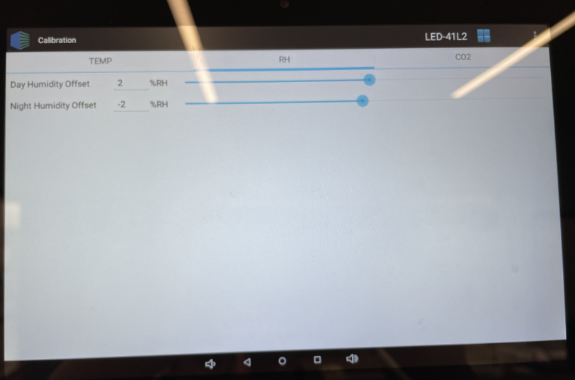RH

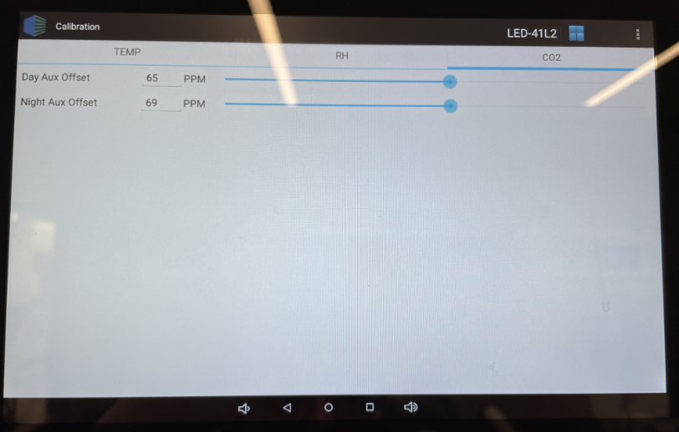CO2